II AI & ML
WEBAPPLICATIONS DEVELOPMENT LAB
DATE: 18.4.2023
Experiment 7: Design and development of online banking using JSP/Node.js & React.js
About Online Banking:

What Is Online Banking?
Online banking allows you to conduct financial transactions via the Internet. Online banking is also known as Internet banking or web banking.
Online banking offers customers almost every service traditionally available through a local branch including deposits, transfers, and online bill payments. Virtually every banking institution has some form of online banking you can access through a computer or app.
Using online banking requires a computer, tablet, mobile phone, or other device, plus an Internet connection and a bank or debit card. In order to access the service, you need to register for the bank's online banking service and create a password. Once that's done, you can use the service to do your banking.
Banking transactions offered online vary by institution. Most banks generally offer basic services such as transfers and bill payments. Some banks also allow customers to open up new accounts and apply for credit cards through online banking portals. Other functions may include ordering checks, putting stop payments on checks, or reporting a change of address.

Advantages of Online Banking
Convenience is a major advantage of online banking. Basic banking transactions such as paying bills and transferring funds between accounts can easily be done any time of the day or night, seven days a week.
Online banking is fast and efficient. Funds can be transferred between accounts almost instantly, especially if the two accounts are held at the same institution.
You can open and close a number of different accounts online, from fixed deposits to recurring deposit accounts that typically offer higher rates of interest.
You can also monitor your accounts closely, allowing you to keep your accounts safe. Around-the-clock access to banking information provides early detection of fraudulent activity.

Disadvantages of Online Banking

Although online banking security is continually improving, such accounts are still vulnerable when it comes to hacking. Customers are advised to use their own data plans, rather than public Wi-Fi networks, when using online banking to prevent unauthorized access.

To implement the above application, we need to create or design the following code:

// SORUCE CODE TO CREATE A SERVELET

package g;

import java.io.IOException;

import java.io.PrintWriter;

import java.rmi.Naming;

import javax.servlet.RequestDispatcher;

import javax.servlet.ServletException;

import javax.servlet.http.HttpServlet;

import javax.servlet.http.HttpServletRequest;

import javax.servlet.http.HttpServletResponse;

public class CreateServlet extends HttpServlet {

public void doGet(HttpServletRequest request, HttpServletResponse response)

throws ServletException, IOException {

response.setContentType("text/html");

PrintWriter out=response.getWriter();

String username=request.getParameter("username");

String password=request.getParameter("password");

String repassword=request.getParameter("repassword");

String amoun=request.getParameter("amount");

double amount=Double.parseDouble(amoun);

String adderess=request.getParameter("adderess");

String ph=request.getParameter("phone");

double phone=Double.parseDouble(ph);

//double mname=Double.parseDouble(num);

//String country=request.getParameter("country");

int status=RegisterUser.register(username, password, repassword, amount, adderess,phone);

if(status>0){

out.print("WELCOME! YOUR ACCOUNT HAS OPENED");

RequestDispatcher rd=request.getRequestDispatcher("index.jsp");

rd.include(request, response);

}

else{

out.print("Sorry,Registration failed. please try later");

RequestDispatcher rd=request.getRequestDispatcher("MyHtml.html");

rd.include(request, response);

}

out.close();

}

}

//CODE TO INITIALIZE A DATABASE

package g;

public interface DBIntializer {

String DRIVER="oracle.jdbc.driver.OracleDriver";

String CON_STRING="jdbc:oracle:thin:@localhost:1521:xe";

String USERNAME="system";

String PASSWORD="oracle";

}

//CODE FOR DETAILS

package g;

// THIS PROGRAM GBANK IS THE INTERFACE FOR THE MAIN PROGRAM

import java.rmi.*;

public interface Details extends Remote

{

public int open(String username,String password,double amount,String adderess,double phone) throws RemoteException;

public String withdraw(int acno,String uname,String pwd,int amt) throws RemoteException;

public String deposit(int acno,String uname,String pwd,int amt) throws RemoteException;

public String transfer(int acno,String uname,String pwd,int tacno,int amt) throws RemoteException;

public String close(int acno,String uname,String pass) throws RemoteException;

public String balance(int acno,String uname,String pass) throws RemoteException;

}
//CODE FOR USER REGISTRATION
package g;
import java.sql.*;

import g.GetCon;
public class RegisterUser {
static int status=0;
//int accountno=1;
public static int register(String username,String password,String repassword,double amount,String adderess,double phone){
//public static int register(String email,String password,String gender,String country,String name){

Connection con=GetCon.getCon();
PreparedStatement ps;
try {
ps = con.prepareStatement("Insert into NEWACCOUNT values(?,?,?,?,?,?,?)");
int nextvalue1=GetCon.getPrimaryKey();
ps.setInt(1,nextvalue1);
ps.setString(2,username);
ps.setString(3,password);
ps.setString(4,repassword);
ps.setDouble(5,amount);
ps.setString(6,adderess);
ps.setDouble(7,phone);

status=ps.executeUpdate();

} catch (SQLException e) {

e.printStackTrace();
}
return status;

}
}

//CODE FOR VERIFY LOGIN

package g;
import java.sql.Connection;
import java.sql.PreparedStatement;
import java.sql.ResultSet;
import java.sql.SQLException;
public class verifyLogin1 {
public static boolean checkLogin(int accountno,String username,String password){
boolean status=false;
Connection con=GetCon.getCon();
try {
//PreparedStatement ps=con.prepareStatement("Select * from MAILCASTINGUSER where EMAILADD = ? and PASSWORD =?");
PreparedStatement ps=con.prepareStatement("Select * from NEWACCOUNT where accountno=? and username = ? and password =?");
ps.setInt(1,accountno);
ps.setString(2,username);
ps.setString(3,password);
ResultSet rs=ps.executeQuery();
status=rs.next();

} catch (SQLException e) {
e.printStackTrace();
}
return status;
}
}

OUTPUT SCREENS:-

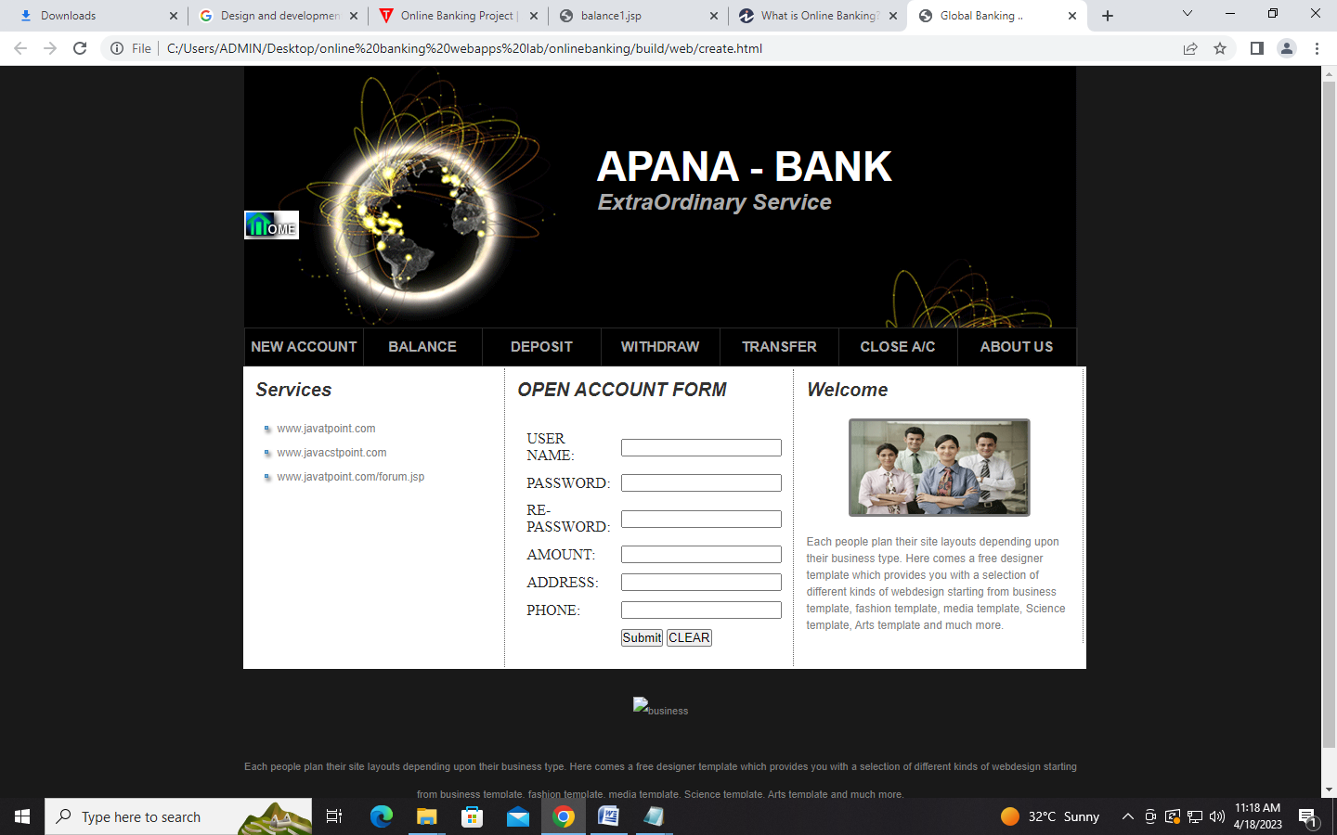

FIG: OPENING NEW ACCOUNT FORM

BY CLICKING ON NEW ACCOUNT, THE ABOVE SCREEN WILL BE DISPLAYED. USER OR CUSTOMER CAN CREATE NEW ACCOUNT IN THE BANK.

SIMILARLY, FOR THE REMAINING MENUS LIKE BALANCE, DEPOSIT, WITHDRAW,TRANSFER, CLOSE A/C AND OTHERS ARE ALSO DESIGNED IN THIS APPLICATION.

Balance MENU:- This menu is used to show the balance of amount in the account.
Deposit Menu:- This menu is used to deposit some amount in our account.
Withdraw Menu:- This menu is used to withdraw amount form our account.
Transfer Menu:- This menu is used to transfer amount to the recipient by providing account number, name, amount, purpose to transfer amount, IFSC Code etc.
Close Account: If we want to close the account which no longer be needed then we will use this option.

